|  |  |
| --- | --- |
| **Register No:** | **99220040341** |
| **Name:** | **P Vinay Saran** |
| **Class/Section:** | **SLOT-1 / S-04** |
| **Ex.No:** | **9** |
| **Date of Submission** | **25.02.2025** |
| **Name of the Experiment** | DHCP Configuration |
| **Google Drive link of the packet tracer file**  **(give view permission):** | [**https://drive.google.com/drive/folders/1bLan6W49r_UgFkfhcUerA7JEZjCIoqgm?usp=sharing**](https://drive.google.com/drive/folders/1bLan6W49r_UgFkfhcUerA7JEZjCIoqgm?usp=sharing) |

**Objective(s):**

To design and implement DHCP configuration using packet tracer

**Introduction:**

Dynamic Host Configuration Protocol or DHCP is a networking protocol that allows for the automatic assignment of IP addresses to devices in a network. You have probably seen DHCP in action at the most basic level when you connect your laptop to an ISP router (like MTN-HynetFlex) or your phone's hotspot. Every new device that joins the Wifi network will get a local IP address, usually in the range 192.168.0.* or 172.16.*.* where * is a number between 0 and 255.

Without DHCP, these massive networks will require physical agents in call centers to manage who gets what IP address. While this is not only a hassle, it will be a huge cost to the service provider.

One easy way to practice a DHCP setup is in a local network simulation environment like Cisco Packet Tracer. This lab will discuss how to configure DHCP on a router for a simple 4-computer, two-switch network. The router will assign the IP addresses to the computers in each network so that inter-network communication can happen.

1. **Device Requirements:**

1. ROUTER0

2. SWITCH 0

3. SWITCH 1

4. PC0

5. PC1

6. PC 2

7. PC 3

8. PC 4

9. PC 5

10. PC 6

11. PC 7

1. **Network Diagram for your experiment (draw the diagram either hand drawing/ms paint or any other drawing tools)**

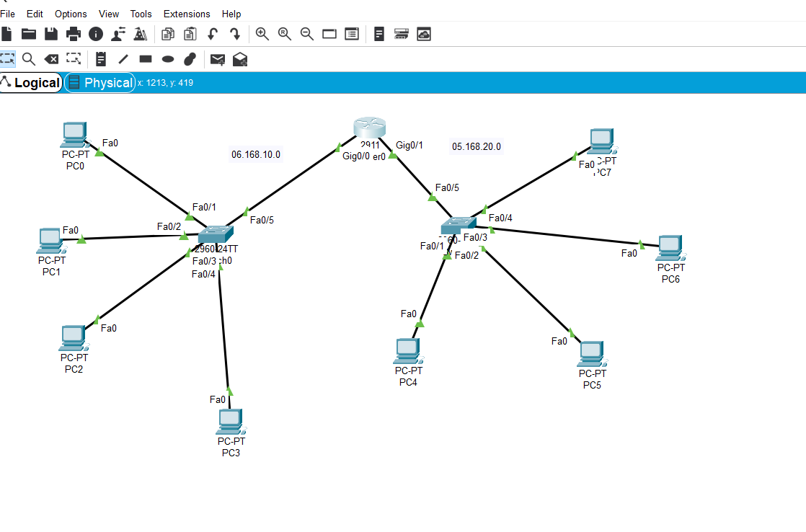

1. **Network Diagram (Packet tracer diagram before configuration):**

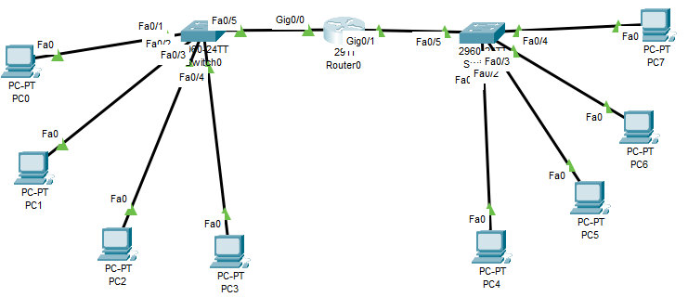

1. **Configuration details:**

|  |  |  |  |  |
| --- | --- | --- | --- | --- |
| **Device Name** | **Interface Name** | **IP Address** | **Subnet mask** | **Default Gateway** |
| PC0 | FA0/1 | 06.168.10.2 | 255.255.255.0 | 06.168.10.0 |
| PC1 | FA0/2 | 06.168.10.9 | 255.255.255.0 | 06.168.10.0 |
| PC2 | FA0/3 | 06.168.10.10 | 255.255.255.0 | 06.168.10.0 |
| PC3 | FA0/4 | 06.168.10.11 | 255.255.255.0 | 06.168.10.0 |
| PC4 | FA0/1 | 05.168.20.2 | 255.255.255.0 | 05.168.20.0 |
| PC5 | FA0/2 | 05.168.20.3 | 255.255.255.0 | 05.168.20.0 |
| PC6 | FA0/3 | 05.168.20.4 | 255.255.255.0 | 05.168.20.0 |
| PC7 | FA0/4 | 05.168.20.5 | 255.255.255.0 | 05.168.20.0 |

1. **Describe step by step configuration steps properly (you may copy the commands used in the configuration tab and paste it.)**

ip dhcp pool 10

network 06.168.10.0 255.255.255.0

default-router 06.168.10.1

exit

ip dhcp excluded-address 06.168.10.3 06.168.10.8

exit

ip dhcp pool 20

network 05.168.20.0 255.255.255.0

default-router 06.168.20.1

exit

1. **Output Diagram (Minimum 3 screenshot):**

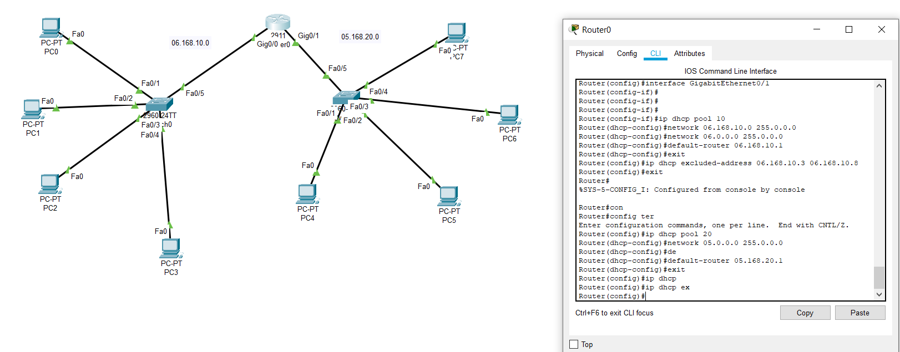

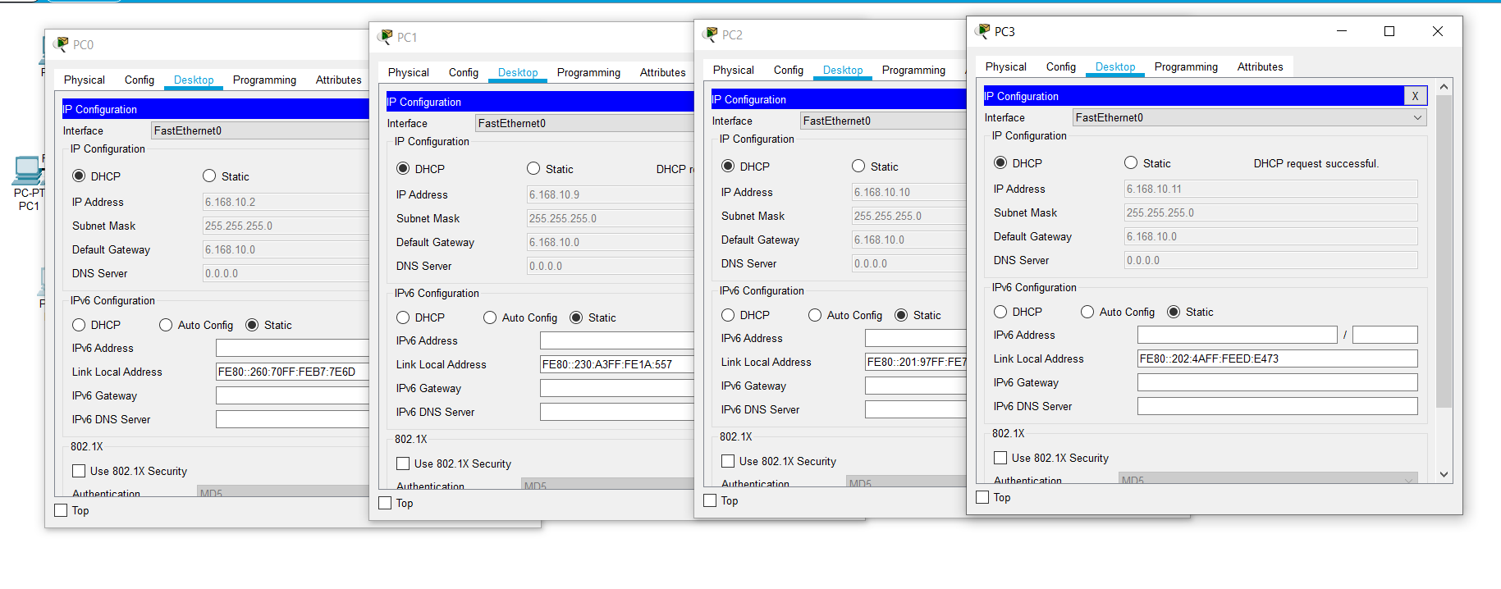

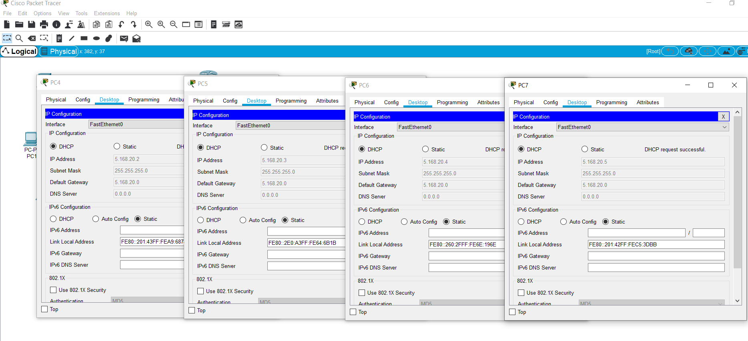

**Rubrics for Experiment Assessment:**

|  |  |  |  |  |
| --- | --- | --- | --- | --- |
| **Rubrics** | **Good** | **Normal** | **Poor** | **Marks** |
| **Creation of Topology (4)** | Created the topology, identified the proper devices and made the connections **(4)** | Created the topology, Identify the proper devices, making the connections But missing some features **(3)** | Created wrong topology, Failed to Identify the proper devices and making connections **(1)** |  |
| **Verify the connectivity (4)** | Verified the connectivity in all the levels **(4)** | Verified the connectivity at some levels (only some nodes) **(2)** | Verified the connectivity is not done. **(1)** |  |
| **Timely Completion (2)** | Completed the lab before the allotted time **(2)** | Completed the lab after the deadline **(1)** | Did not submitted before grading **(0)** |  |
| **Tota**l | | | |  |

**CONCLUSION (provide conclusion about this experiment):**

Thus the design and implementation of DHCP Configuration using Packet Tracer is Successfully implemented and Connections are verified.